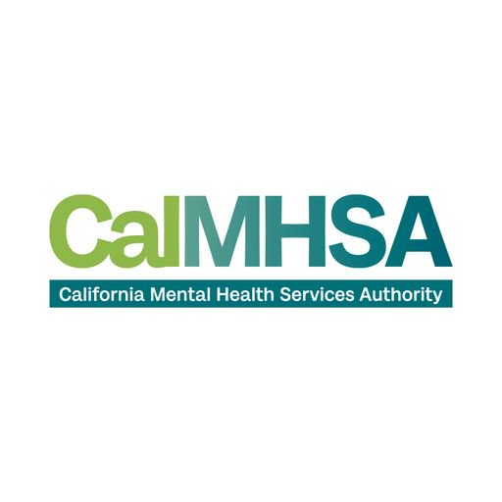
California Mental Health Services Authority
Vendor ACH Form
This form is used for Automated Clearing House (ACH) enrollments. Please fill out all sections of the form. Once complete, please submit the form to accountspayable@calmhsa.org for processing.
If for any reason a vendor wishes to cancel or change their ACH enrollment status, the onus is on the Vendor to notify CalMHSA.
Vendor Information
Vendor Name:
Vendor Tax ID:
Street Address:
City, State, Zip:
Contact Person Name:
Contact Number:
Contact email:
Financial Institution Information
Branch Name:
Account type: Checking Savings
Bank telephone number:
Routing Number (9 digits):
Account Number:
Authorized name:
Authorized Title:
Authorized signature: Date:

